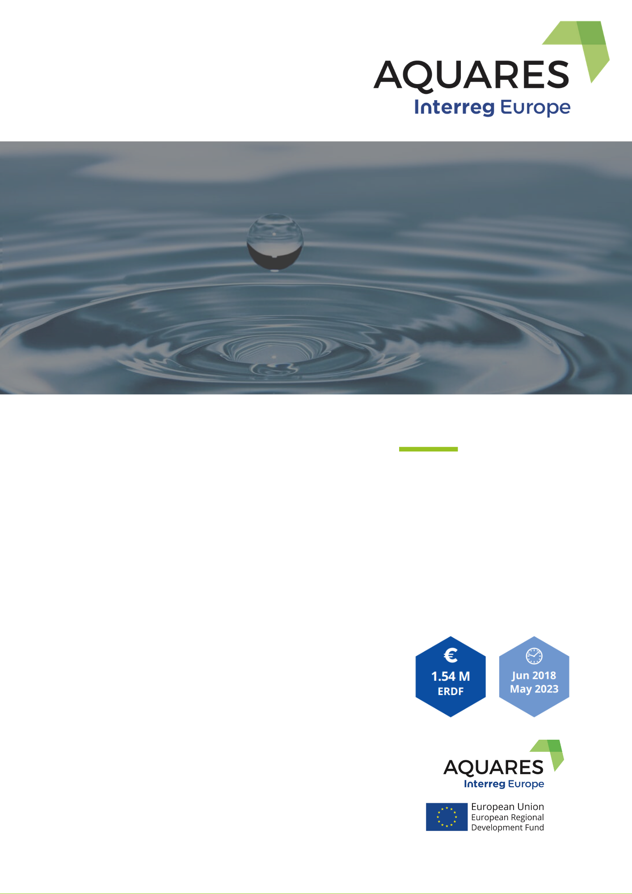

**CONTENTS**

**A NEWSLETTER ON THE PROGRESS AND UPCOMING ACTIVITIES OF THE AQUARES PROJECT**

* The first study visit in region Lodzkie
* Partners activities
* News by AQUARES partners

During the second and third semesters of the project implementation, partners have advanced with the research activities on water reuse technologies and practices and the monitoring practices used in their territories. Specifically, the first study visit to transfer experience on water reuse implementation and monitoring issues was organized by region Lodzkie in October in Poland. There, the steering group meeting of the partners also took place, in Lodzkie region.

*“AQUARES – Water reuse policies advancement for resource efficient European regions” is a project under the INTERREG Europe programme that aims to improve the implementation of regional development policies and programmes in the partnership regions, to increase resource efficiency, green growth, and environmental performance management in the water reuse sector. The project brings together 10 public organisations from 9 different European countries with the aim to achieve better water management of water resources through water reuse.*

**SUPPORTING WATER EFFICIENCY THROUGH WATER REUSE**

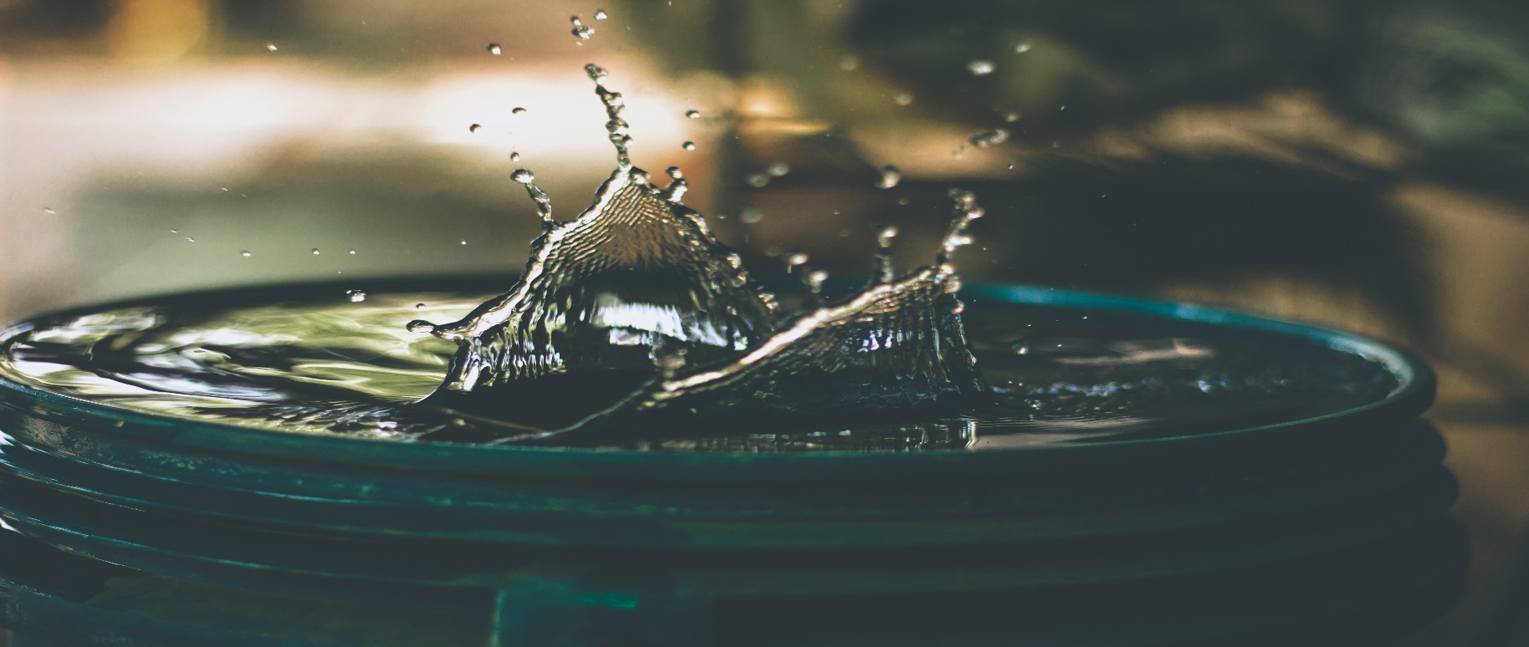

**NOVEMBER 2019 | VOL. 3**

**AQUARES NEWSLETTER**

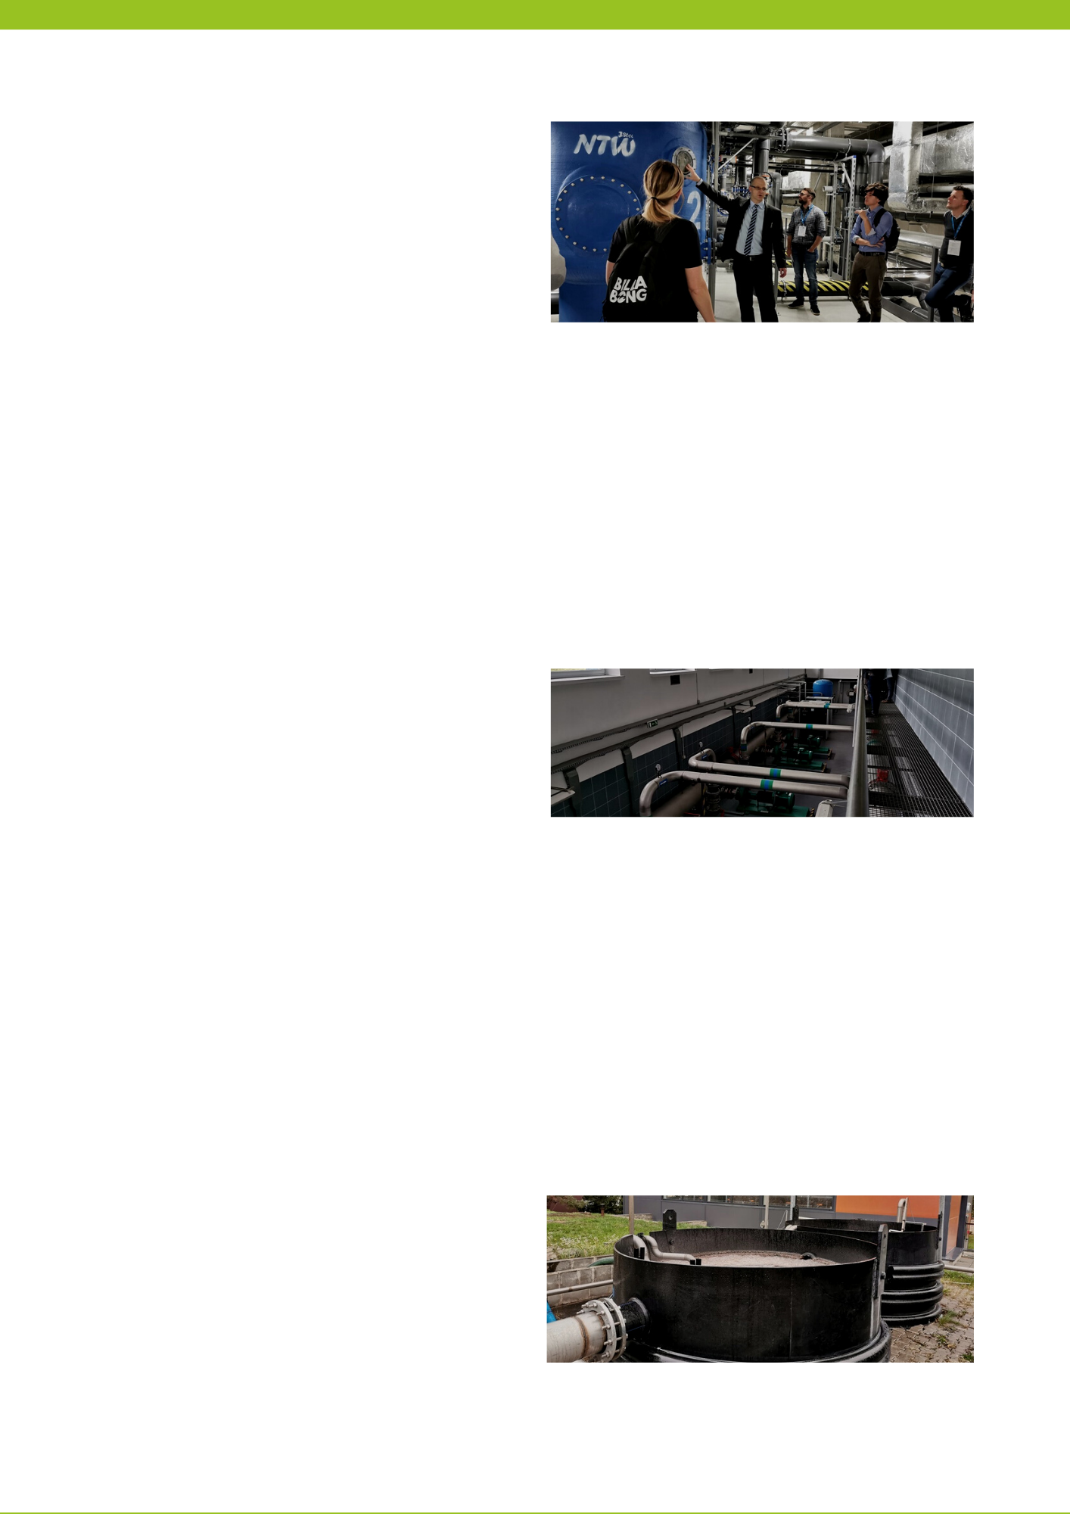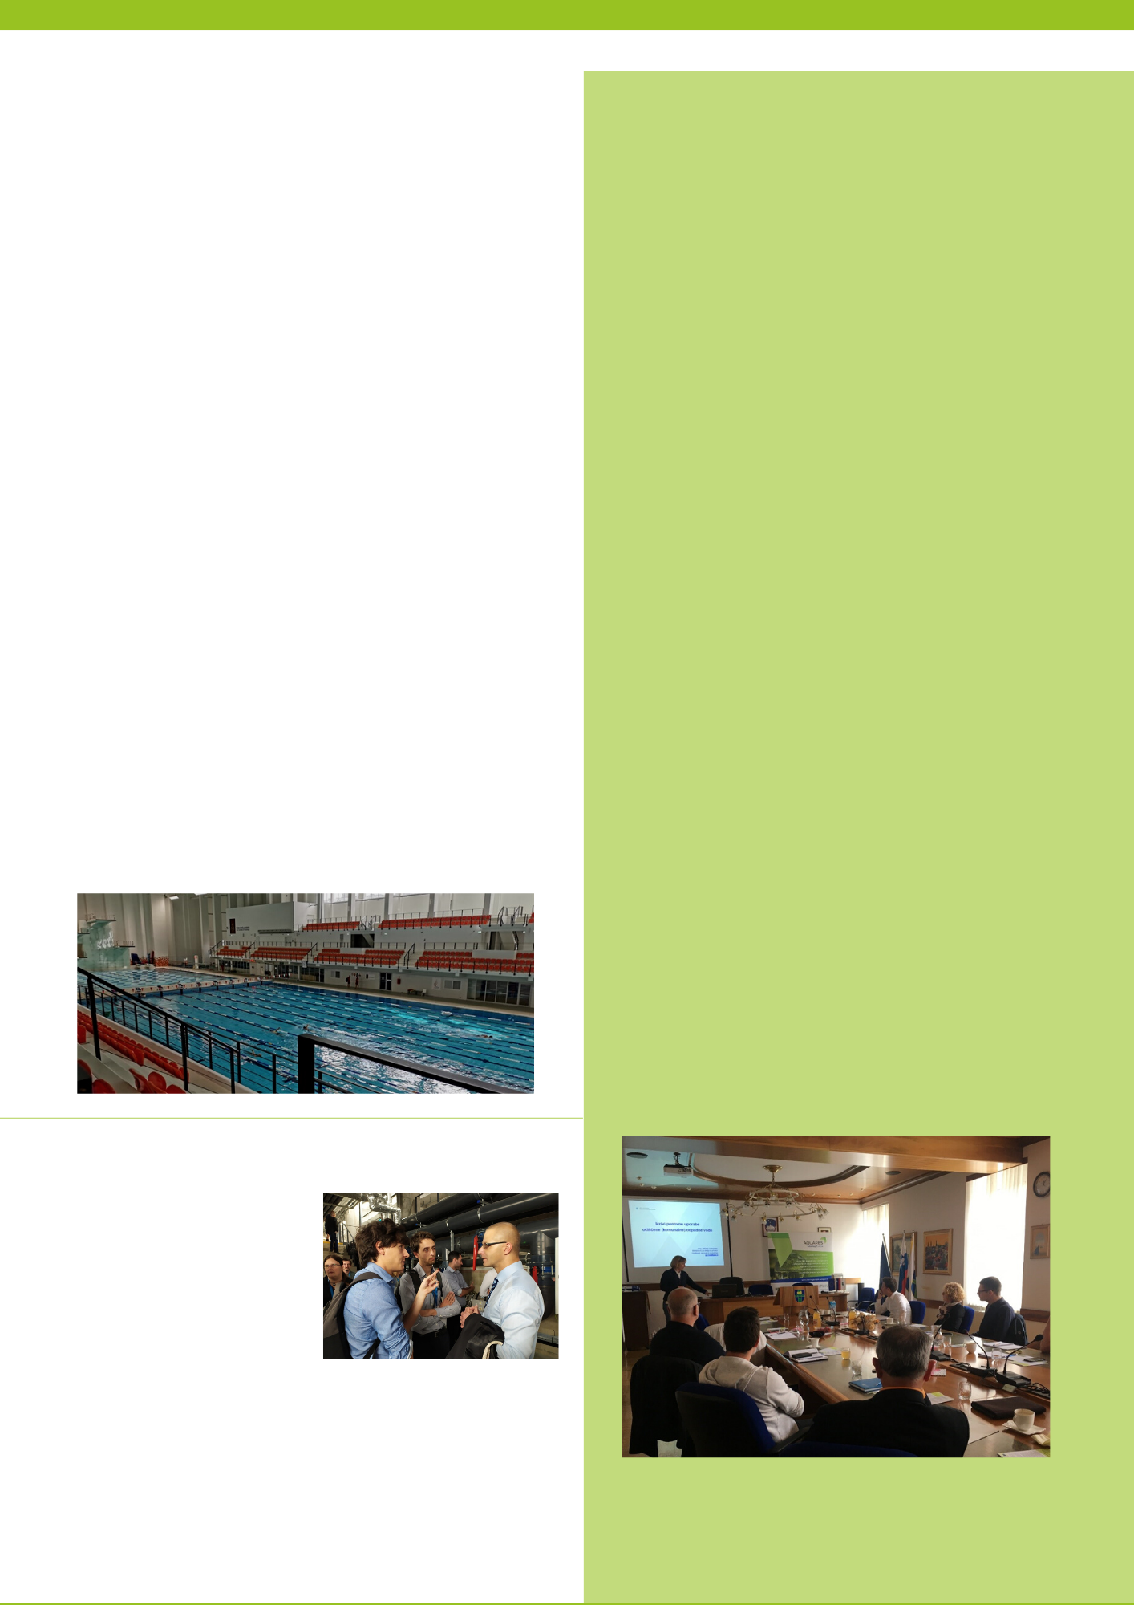

The second day of the study visit guests were introduced to the project "Ecohydrological reclamation of recreational reservoirs Arturówek in Łódź as a model approach to urban reservoirs reclamation (EH-REK)". The activities implemented within the project limit the inflow of pollutants from the municipal catchment area to water reservoirs and the Bzura River. The principle of their operation is the concept of a sequential sedimentation and biotransfer system (SSSB). The solutions applied in Arturówek on the upper reservoir not only have a positive impact on water quality, but also improve biodiversity and provide habitats for living organisms.

Thanks to this, about 40-50% of water intake is reused. Wastewater which is not suitable for reuse, i.e. which could cause adverse effects on the biological treatment plant, is also treated with the coagulation method and flocculation, and then directed to the sewerage system. The latest project of the company is based on the separation of colored sewage, characterized by high salinity (salt content reaching 80g/ml), very high pH, strongly colored (impervious to light). After applying appropriate physico-chemical methods, the wastewater is treated to such an extent that it can be reused for staining.

Water scarcity has become increasingly severe in recent decades and demand for water continues to grow. EU Member States are looking for solutions to improve water quality and reuse. One of the main objectives of the AQUARES project is the exchange of knowledge in the field of efficient water management between the project partners and the recognition of specific technological solutions to improve the water balance in the EU countries.

On 16 and 17 October 2019, experts from the AQUARES project partnership countries, i.e. Spain, Czech Republic, Malta, Latvia, Slovenia, Italy and Germany, learned about innovative water treatment technologies implemented in the łódzkie region.

On the first day of the study visit, the participants visited the Municipal Water and Sewage Treatment Plant in Sieradz and the "Biliński" Textile Factory in Konstantynow Lodzki.

Treatment Plant in Sieradz provides services for the inhabitants of the Sieradz agglomeration covering the City of Sieradz and the surrounding rural areas of the Municipality of Sieradz. During two-stage treatment of water collected from sources (iron and manganese removal) using DynaSand filters, so called rinse water is created. The applied technologies purify the rinse water, separating and thickening the sludge, and the supersedimentary water is returned to the filter again. In other words, the rinse water is cleaned of dense impurities and the recovered water is returned to the treatment again. It is estimated that the technology used minimises the use of rinse water by approximately 10%. The technology used in MPWiK in Sieradz was implemented in cooperation with AWP Nordic Products Sp. z o.o. from Łódź.

The project of sewage treatment and closing water circuits in the "Biliński" Textile Plant was carried out on the basis of BAT (Best Available Techniques) guidelines - the best available techniques for the textile industry.

**STUDY VISIT ON INNOVATIVE TECHNOLOGIES OF WATER TREATMENT, RECOVERY & MONITORING IN THE LODZKIE REGION | 10-2019**



On 28 May, Municipality of Trebnje organized 2nd stakeholders meeting, dedicated to Linkage with other policies: land-use CAP, urban planning and water demand management towards water reuse. The event was attended by researchers, representatives of the ministry, wastewater treatment plants, companies and local authorities.

The first presentation was delivered by Nataša Atanasova, Ph.D. Associate professor from Faculty of Civil and Geodetic Engineering, University of Ljubljana with a title Water in circular economy. Second presentation was delivered by Andrej Udovč, Ph.D. from Biotechnical faculty, University of Ljubljana. He presented aquaponics as a sustainable production that involves the cultivation of vegetables with a decrease in water consumption of up to 90% with respect to traditional farming practices, by recycling wastewater from fish farms. In the last session, Nataša Vodopivec, MSc from the Ministry of Environment and Spatial Planning, explained a preparation process of national guidelines for water reuse in Slovenia.

At the meeting, the obstacles that need to be overcome for the wider implementation of water reuse in Slovenia were identified: 1) policy development, 2) rising social acceptance, 3) upgrading existing water infrastructure and 4) supporting research and enriching knowledge about water reuse implementation possibilities.

***Stakeholders meeting in Trebnje, Slovenia***

Picture above: Students (from the left) Jacopo Foschi and Riccardo Delli Compagni with head director from Gulf of Sport at Lodzkie region.

Lombardy Foundation for the Environment (FLA) took part in the Study Visit organized by the Lodzkie Region in Poland. For the occasion, FLA invited two young PhD students from the Polytechnic of Milan, who had the opportunity to expand their knowledge in this field and present their research to a large audience of international experts.

***Participation of students from Italy at study visit at Lozdkie region***

Another place for the study visit was the Academic Sports and Didactic Centre of the Lodz University of Technology Sport Bay. Re-use of water in swimming pools there consists in the operation of overflows in a closed circuit. Both swimming pools in the Sports Bay are equipped with overflow gutters, by means of which splashed water goes to the tank in the underbasin. These tanks are covered to avoid evaporation. Water circulating in a closed circuit is subjected to disinfection and filtration. For this purpose, pressure filters are used, consisting of about 200 candles. Water enters the filter under pressure and is filtered through diatomaceous earth, which is saturated with material around the "snail" of the filter. Chlorine is added to the water treated in this way, which is produced on site in an electrolyzer. NaCl salt forms a salt arc and chlorine in the form of gas, which is much more efficient than liquid chlorine. The water then flows through the UV lamp. The photo-oxidative disinfection lamp effectively neutralizes bacteria, viruses and other microorganisms and blocks their multiplication. Then the water returns to the pool with a system of pipes and bottom jets (in the amount of nearly 100). Within 1 day it can be estimated that in a swimming pool with a total volume of 3 300 m3 water is replaced on average three to four times. Monitoring of the quality of pool water is carried out continuously.

**PARTNERS ACTIVITIES**

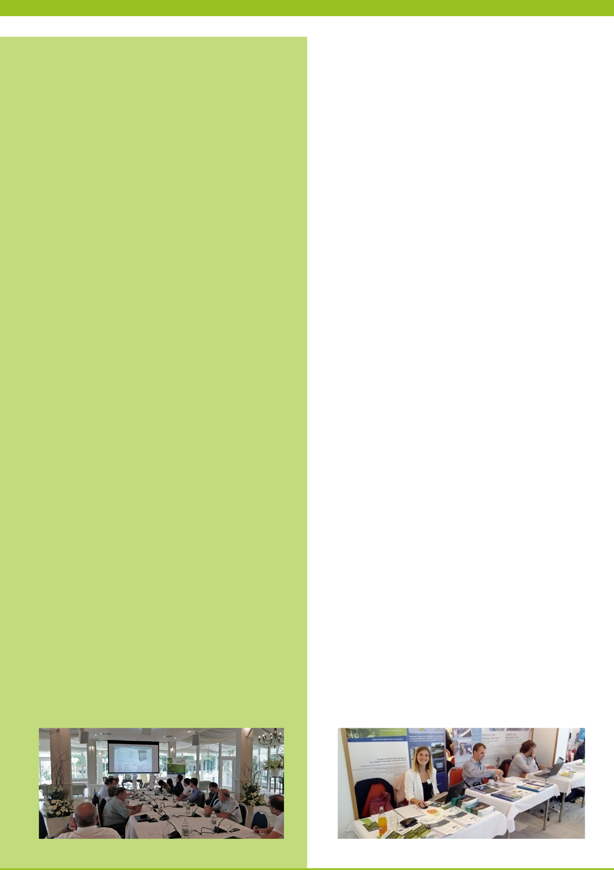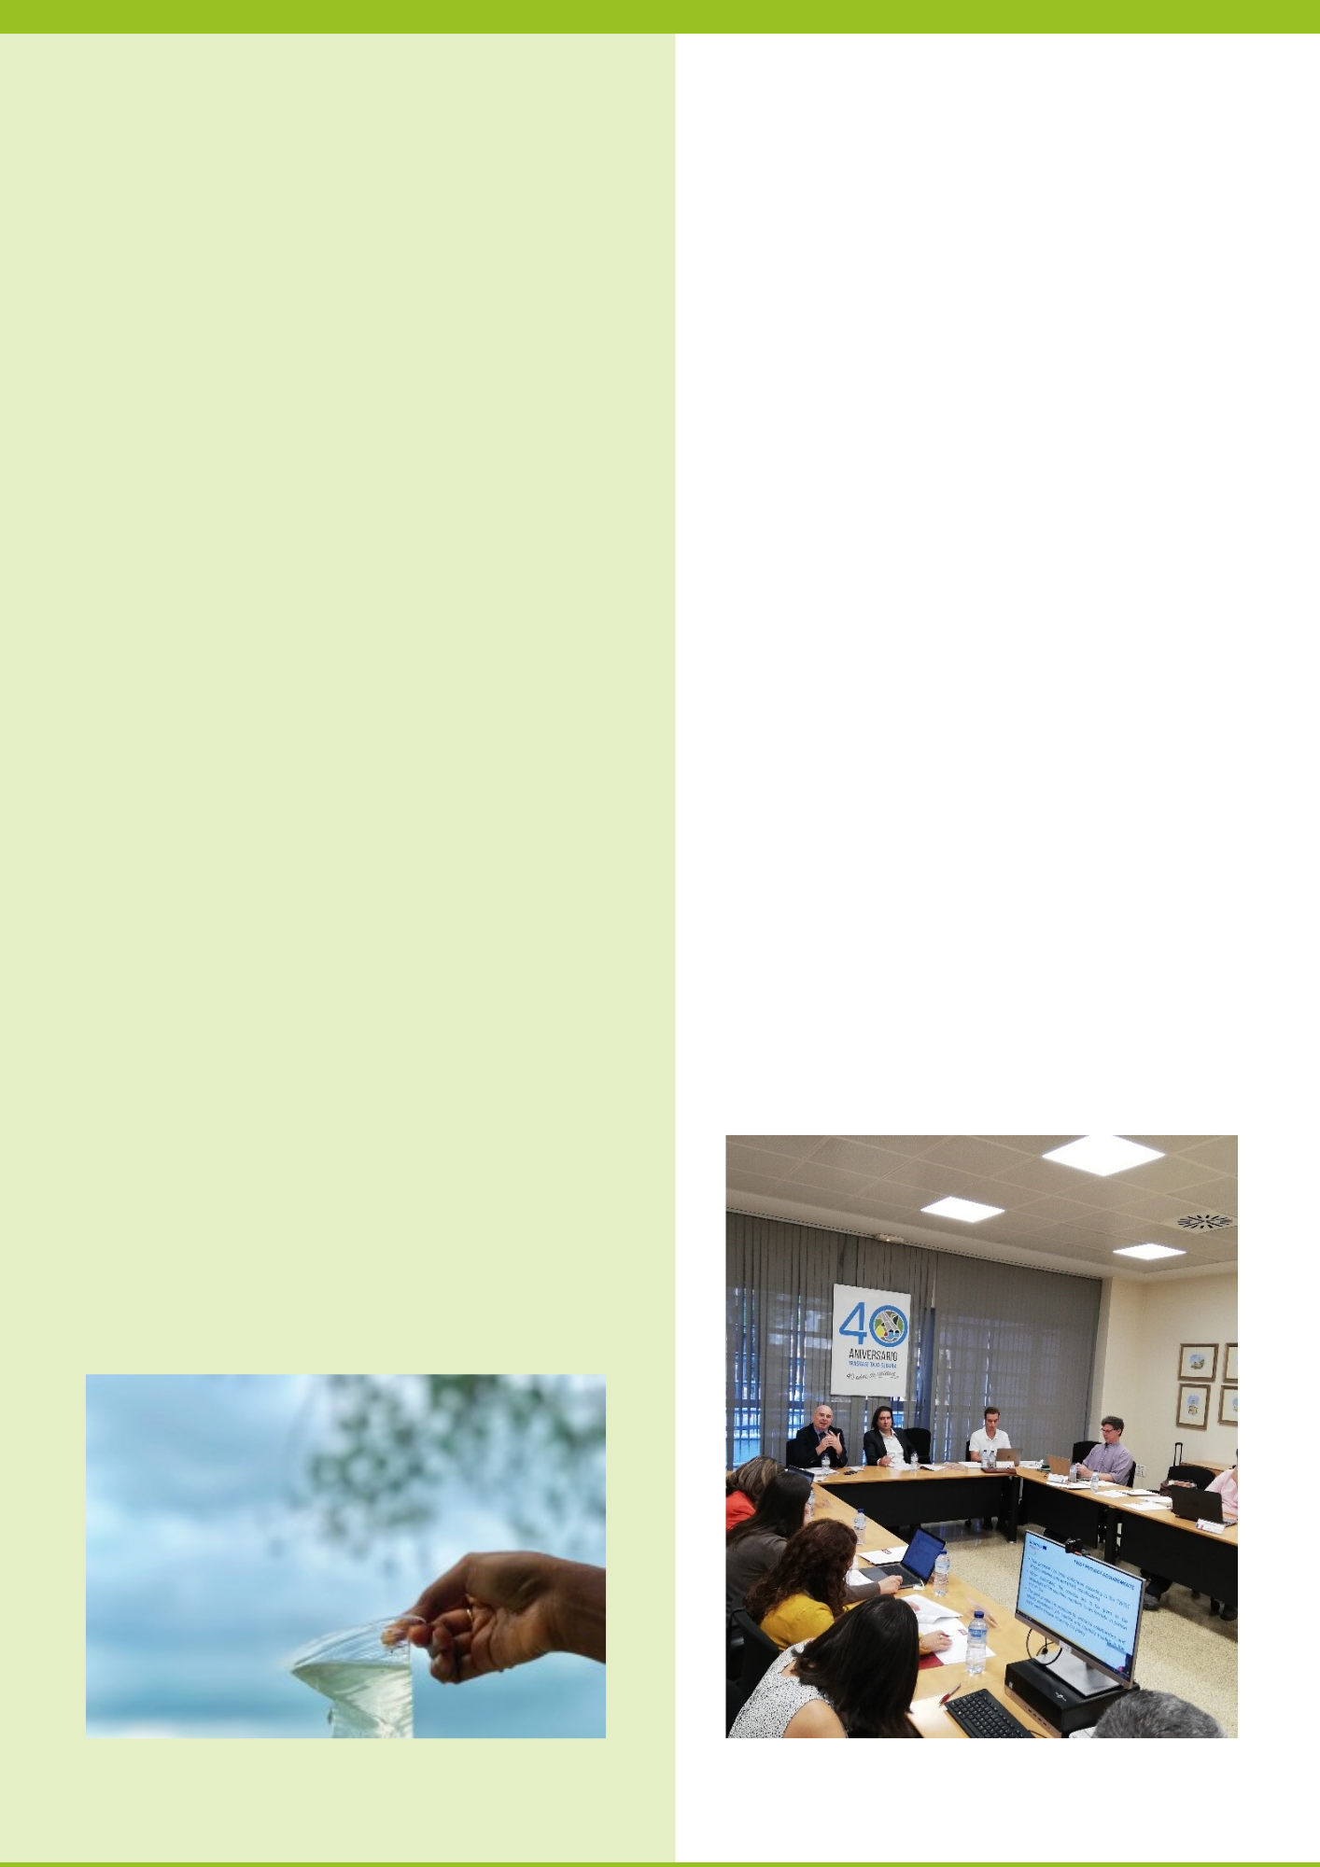

In September, partners of the AQUARES project from the Czech Republic, The Regional and Development Agency of Pardubice region, participated in the 13th Biennial Conference - VODA 2019, organized by the Association for Water in the Czech Republic in Poděbrady. “The Biennial Conference VODA is the flagship conference of the Association for Water of the Czech Republic and a forum for meeting a wide range of participants in the field of water management and environmental protection, their goal is the sustainable development of society.

This year, the conference tried to define the current key areas for research and further direction of water management in the Czech Republic. During the conference the AQUARES project presented itself in the part of exhibitors with its activities and made new contacts with conference participants. The conference included topics such as drinking water, water quality at the effluent from the waste water treatment plant, specific pollutants in surface waters and ecosystems, sewer networks and water protection, reuse of waste water and sludge, rainwater and many others.

The last day of the conference was devoted to a visit to the Field Hydrogeological Center Friday. This center is a unique infrastructure for research development and innovation in the field of environmental engineering, especially with an emphasis on the care and management of water resources. The center is equipped with an extensive network of hydrogeological objects, which are complemented by others selected for the purposes of simulation of specific processes, their control and monitoring. The site has a so-called hydrogeological radar, which provides online data on groundwater parameters at the site and archives them.

***Participation at the third party event in Czech Republic – WATER 2019 in Poděbrady city***

**OTHER PROJECT NEWS**

**PARTNERS ACTIVITIES**

***The Energy and Water Agency hosted the 3rd Stakeholders meeting, which focused on waste water reused technologies***

On the 7th of October 2019, representatives of stakeholder organisations coming from sectors such as the water, the environmental, the commercial, the development and the health sectors were invited to participate in the 3rd regional stakeholders meeting held under the AQUARES project. The Energy and Water Agency (EWA) invited specific speakers to present opportunities for integrating the advances of water reuse technologies in national and regional water policies.

One of the purposes of this stakeholders meeting was to present to the attendees information about technologies used for the treatment of waste water and its reuse. The technologies currently used in Malta’s wastewater treatment plants and polishing plants were discussed, where speakers from the Water Services Corporation, Malta’s national water utility, explained the different technologies used. The improvements made in this technology recently shows that the advancements in energy recovery is improving, thus reducing the energy required to treat and polish water, reducing operational costs. Other presentations focused on alternative technologies which are used in other European countries, and their potential adoption in the local context were also discussed.

The other purpose of this meeting was to obtain feedback from these different sectors about the adoption of new technologies in the water reuse sector. This in particular to the needs to ensure the safety of reclaimed water as well as the public’s understanding and appreciation of the capacity for the delivery of a safe product.  This being a major facet for increasing the acceptability and use of reclaimed water.

The Euro-Mediterranean Water Institute Foundation collaborates with ENAE Business School and the General Water Directorate of Murcia, by taking part of the presentation of the International Business School for the Water Sector. At the event several representatives, experts on water field, were involved coming from countries such as Portugal and France.

The presentation was held at the headquarters of the DGA, last 9th October, implying the arrangement of an initial formation program of training courses (attended and online) focused on desalination, water reuse, transfer, aquifer management, water governance and integrated management for agriculture.

The courses are designed by the IEA Foundation together with subject matter experts such as Mr David Martínez Vicente (CARM), Mr Andrés Molina and Mrs Mª Ángeles Bernal del Hombre Bueno (both from the University of Alicante), Mr José Luis García Aróstegui from the Spanish Mining and Geology Institute (IGME) and Francisco Pedrero Salcedo from General Direction of Nature Conservation (CEBAS-CESIC).

***F-IEA collaborates with ENAE in the presentation of the International Business School for the Water Sector***

***Minister for the Environment and Regional Development of Latvia participates in a meeting of the EU Council of Ministers for the Environment that was held in Luxembourg***

In the meeting the recent EU Water Reuse Regulation was discussed. The purpose of the Water Reuse Regulation is to contribute to the reduction of water scarcity across the EU by introducing re-use of wastewater for irrigation of agricultural land.

Due to differences in geographical, climatic and environmental conditions, all EU Member States do not share similar solutions for efficient use and protection of water resources. It is urgent for Latvia that the EU water policy and its instruments do not require standard solutions in all EU Member States. Latvia believes that Member States need discretion in choosing the most appropriate solutions for their circumstances in order to find a compromise between the environment, the protection of human health and the sustainable use of water resources.

The Minister for the Environment and Regional Development Juris Pūce emphasizes: “I am convinced that Latvia must be able to adapt to the EU's common move towards an environment policy that is more bold and decisive in the face of climate change. Taking into account the effects of climate change and adapting to it by developing new economic sectors and jobs, Latvia can become one of the countries that successfully exploit these opportunities.”

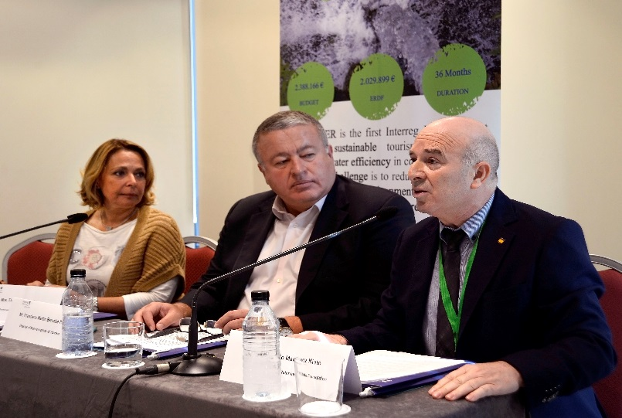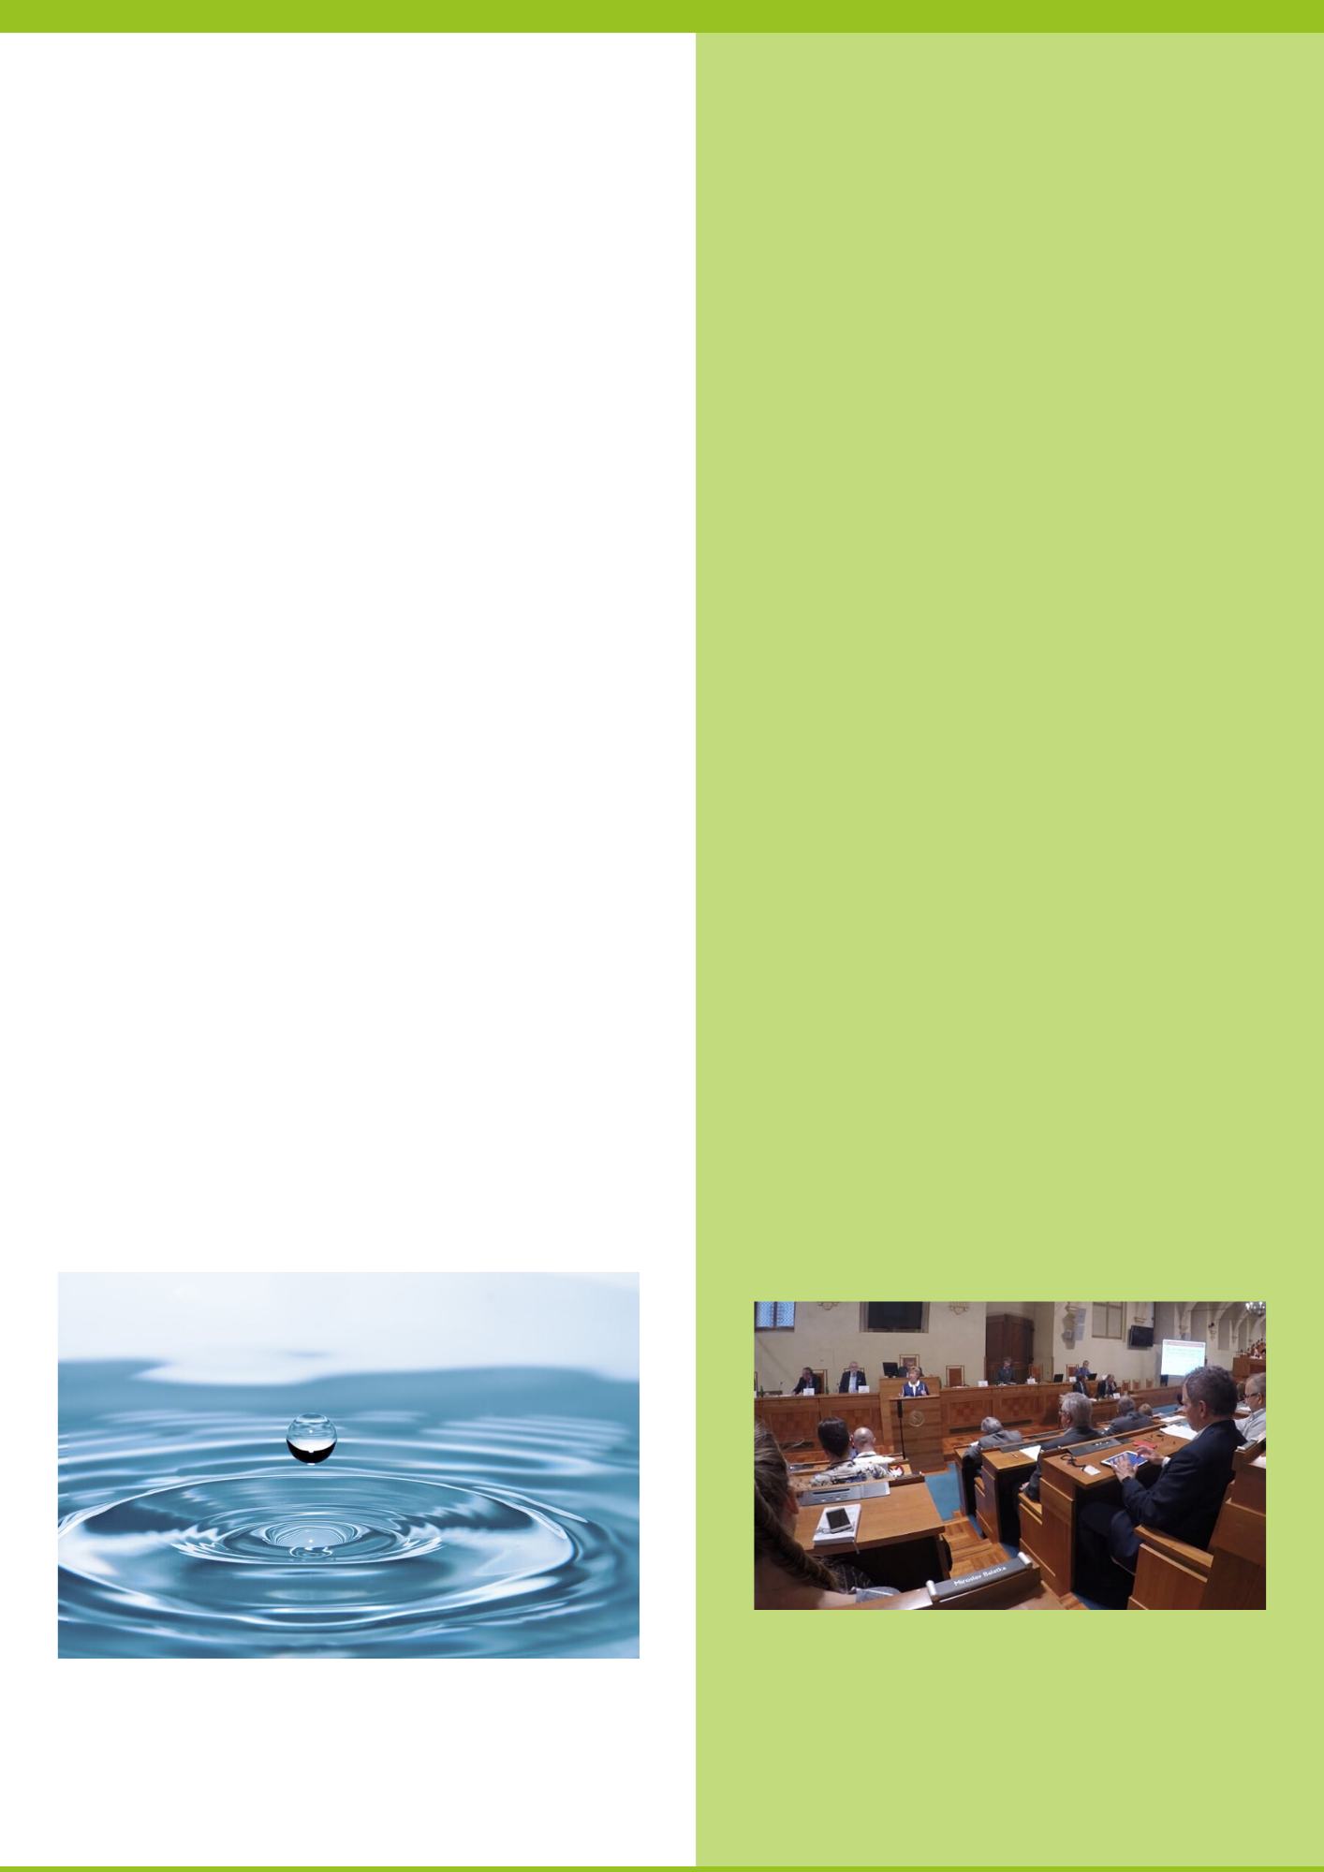

On October 15, 2019, a seminar on Drinking Water for the 3rd Millennium was held in the Senate of the Czech Republic. The event was organized by the Standing Committee of the Senate WATER - DROUGHT. The event was held under the auspices of Jiří Oberfalzer, Vice-President of the Senate. The seminar is organized by the member of the Board of the Standing Committee of the Senate WATER - DROUGHT Ing. Jiří Burian together with prof. Ing. Jiří Wanner, DrSc. from the Institute of Water Technology and Environment of ICT Prague, who moderated the whole seminar.

The topic of the seminar regarded all aspects of drinking water production, quantity and quality of resources, water infrastructure and legislative issues. One contribution relates to the recycling of water (treated waste water) as a way to save drinking water and as a measure against drought.

Chairmen of the Standing Committee of the Senate WATER - DROUGHT Ing. Jiří Burian formulated conclusions and recommendations arising from seminars that will be forwarded to further commission meetings and at the governmental level. The seminar was attended by over one hundred senators and leading industry experts.

***The Regional Development Agency of the Pardubice region participate at the seminar on Drinking Water for the 3rd Millennium at the Czech Republic***

The consortium of the CASTWATER project is completing the 36-months of work at its last meeting in Murcia, at the Siete Coronas Occidental Hotel, on the occasion of the Sustainable Tourism Water Management Conference-Perspectives for Tourism Development in the Mediterranean Water Scarcity Areas. It was celebrated last 24th of September, where around one hundred professionals from the water and tourism sector in seven European countries were brought together to exchange information and improve water use in the tourism sector.

The host Mr Antonio Martínez Nieto, Secretary-General of the IEA Foundation welcomed the guests along with Mr Francisco Bernabé, Director of the Tourism Institute of Murcia and Mrs Theopisti Birliraki, vice mayor of Tourism and Culture, Municipality of Rethymno, Greece.

Worth mentioning is the contribution and collaboration of manages of the private sector such as the directors of Parador del Saler and Global Omnium of Valencia (Spain), as well as public authorities, representatives from the Mediterranean countries such as Malta, France, Italy, Croatia, Cyprus, who showed their common concern to make the tourism sector more sustainable in water management in all its activities.

Within the Conference Sustainable Tourism Water Management, the AQUARES project has also been promoted among the participants, in peer-to-peer interaction, making attendees identify the other concerns of the Region of Murcia regarding the water efficiency that can be achieved through water reuse.

***The CASTWATER Conference is celebrated in Murcia***

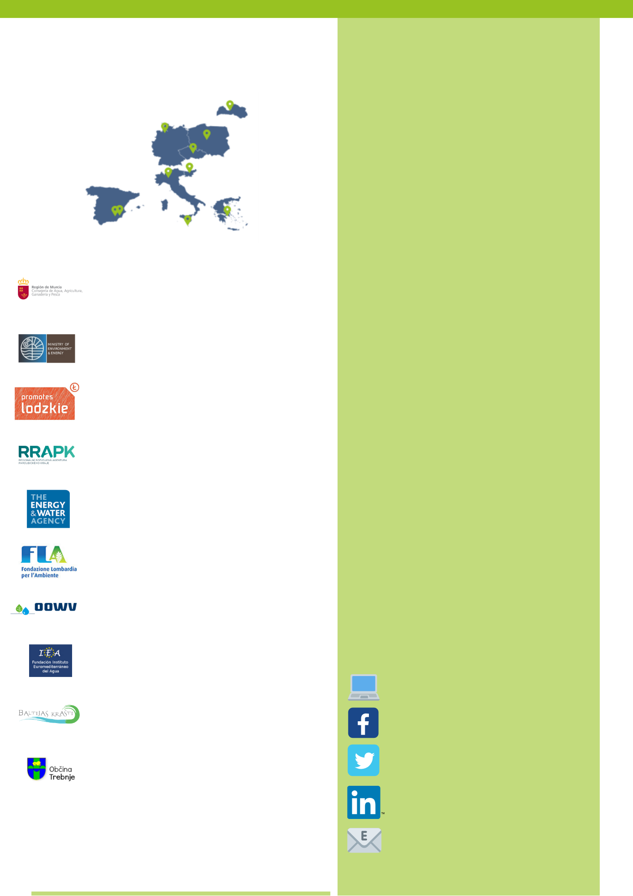

**WORKHOP AND STEERING GROUP MEETING, GERMANY, SPRING 2020**

**Thematic focus:** Interregional workshop on water reuse standardisation

**Host organisation:** Water Board of Oldenburg and East Frisia  
**Date:** 3rd – 4th March 2020  
**Language:** English  
**Number of participants:** 20-25  
**Type of participants:** Partners, regional authorities officials, stakeholders, external experts  
**Contact details:** Silke Mollenhauer  
T: 0171 910 17 22  
E: [mollenhauer@oowv.de](mailto:mollenhauer@oowv.de)

**THE PARTNERSHIP**

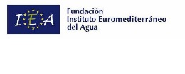

facebook.com/projectAQUARES/

linkedin.com/in/projectAQUARES

twitter.com/projectAQUARES

**STUDY VISIT ON WATER REUSE, CZECH REPUBIC, SPRING 2020**

**FOLLOW US**

**Thematic focus**: Study visit to transfer experience on Water reuse implementation and monitoring issues.

**Host organisation**: The Regional and Development Agency of Pardubice Region  
**Location**: Pardubice region, Czech Republic

**Date**: April, May 2020

**Language**: English

**Number of participants**: 20-25

**Type of participants**: Partners, regional authorities officials, stakeholders, external experts

**Contact details**: Lucie Balcarová, Jan Gregor

T: +420 7280 765 478; +420 603 235 040

E: [lucie.balcarova@rrapk.cz](mailto:lucie.balcarova@rrapk.cz) [jan.gregor@rrapk.cz](mailto:jan.gregor@rrapk.cz)

(SI) The Municipality of Trebnje

(LV) Association "Baltic Coasts"

(ES) Euromediterranean Water Institute Foundation

(DE) Water Board of Oldenburg and East Frisia

(IT) Lombardy Foundation for the Environment

(MT) Energy and Water Agency

(CZ) The Regional Development Agency of the Pardubice Region

(PL) Lodzkie Region

(EL) Ministry of Environment and Energy, Special Secretariat for Water

(ES) Regional Government of Murcia, Ministry of Water, Agriculture, Livestock and Fisheries, General Direction of Water

interregeurope.eu/aquares/

aquares.eu@gmail.com